PARISH OF COBH

APPLICATION FOR CONFIRMATION IN 2021

For the attention of Confirmation Candidates, your Parents/Guardians,

Please fill this application form and return it to info@cobhcathedralparish.ie
We will be in contact with you as soon as the lifting of restrictions makes us possible to fix dates for the celebrations. We would encourage your family to join us for Mass online each Sunday while it is not possible to be present because of restrictions. You can find us at facebook.com/CobhParish

Please fill in both sides of this form in a clear and readable way
By not replying we understand that you do not wish to go forward for the sacrament of Confirmation at this time.

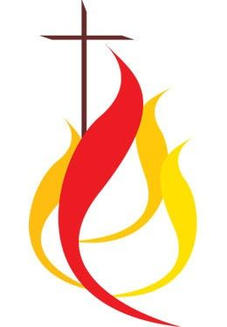

CANDIDATE APPLICATION

Name of candidate for confirmation:

Your chosen confirmation name:

Your sponsor’s christian name and surname:

School Attended:

Teacher’s Name:

Date of birth:

Date of Baptism
(If the exact date is not known, please give an approximate date)
Parish of Baptism:

- If the baptism took place in Cobh parish you do not need to supply a baptism certificate.

For children baptised in other parishes, a baptism certificate must be provided along with this application form before 19th March 2021. This will be available from the parish where the child was baptised.

I wish to receive the Sacrament of Confirmation this year in the parish of Cobh

Signed by Candidate: ………………………………………………………………..
Please Turn Over . . . .
YOUR FAMILY CONTACT DETAILS
Father’s Christian name and surname:
Mother’s Christian name and maiden name:
Family Contact Mobile Number:

Family Contact E-mail address
(please use separated letters)
Family Postal Address

I/We support our child’s application for Confirmation and will help our child in preparing for this Sacrament.

I/We furthermore consent to the information on this application form being used by the parish for the proposes of sacramental preparation and celebration, subject to the relevant General Data Protection Regulations.
Please note: Family contact mobile number and email are required to ensure the parish can maintain effective and timely communication with you as may be necessary.
Privacy Notice and Data Protection Consent
The information in this form will be used by the parish of Cobh where the celebration of your child’s confirmation will take place and to register the confirmation in the appropriate parish. The parish of Cobh is the data controller for the data you provide on this form and can be contacted at info@cobhcathedralparish.ie If your child was baptised in a different parish, information regarding your child’s confirmation will be sent to the parish where your child was baptised so that the confirmation can be registered. The information on the form will not be otherwise shared by the parish. The form will be destroyed within 12 months of your child’s confirmation, however, the information in the Sacramental register will be retained permanently. By signing this form, you consent to the parish of Cobh collecting and processing the data on the form as outlined.

Please return this form (and a copy of the Baptismal Certificate, if required) to info@cobhcathedralparish.ie or to Parish Office, 5 Cathedral Terrace, Cobh, Co. Cork by 19th March 2021.

Signed: ……………………………………… ………………………………………….
Parent(s) / Guardian(s)

